10/05/2025 Briana-Yves 1-1 Meeting Minutes

Unet model training has started on BratTS2017 image datasets

Problem Statement
We don’t have access to the CP images.

Proposed workaround pipeline
We discussed several workaround strategies:
- Train a segmentation model on a curated BraTS 2017 dataset.
- Then fine-tune it on available data:

- 60 Glioblastoma (GBM) cases
- A complete dataset of multifocal GBM cases, with validation performed through the disconnectomics tools or the lesion quantification toolkit (LQT).
- Once available, validate the model on the 90 CP scans.

Tool Description
We also discussed different tools that could be evaluated in relation to MRI scans:

- Neuroimaging-based lesion analyses, such as voxel-based lesion-symptom mapping (VLSM, [1]), which show a lesion’s spatial localization.

- Atlas-based approaches, which measure a lesion’s impact on gray matter regions and white matter connections, as well as the disruption of white matter pathways. One such publicly available tool is the MATLAB Lesion Quantification Toolkit [2].

- Another related analysis is a supervised machine learning method, the Support Vector Regression-based Lesion Symptom Mapping (SVR-LSM), which models the relationship between lesion data and behavioral scores [3].

- Other techniques include disconnection mapping (DSM, [4]) or connectome lesion-symptom mapping (CLSM, [5])

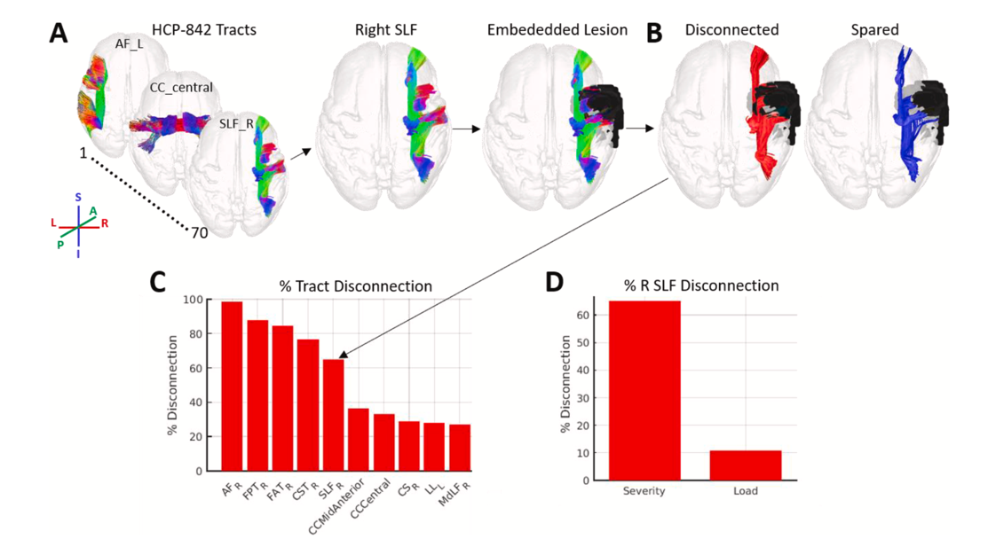
White matter disconnection severity tracts identified by LQT

References
[1] Bates, E., Wilson, S., Saygin, A. et al. Voxel-based lesion–symptom mapping. Nat Neurosci 6, 448–450 (2003). https://doi.org/10.1038/nn1050
[2] Griffis, J. C., Metcalf, N. V., Corbetta, M., & Shulman, G. L. (2021). Lesion Quantification Toolkit: A MATLAB software tool for estimating grey matter damage and white matter disconnections in patients with focal brain lesions. NeuroImage: Clinical, 30, 102639.
[3] Zhang, Y., Kimberg, D. Y., Coslett, H. B., Schwartz, M. F., & Wang, Z. (2014). Multivariate lesion-symptom mapping using support vector regression. Human brain mapping, 35(12), 5861–5876. https://doi.org/10.1002/hbm.22590
[4] Wiesen, D., Bonilha, L., Rorden, C. et al. Disconnectomics to unravel the network underlying deficits of spatial exploration and attention. Sci Rep 12, 22315 (2022). https://doi.org/10.1038/s41598-022-26491-6

[5] Gleichgerrcht, E., Fridriksson, J., Rorden, C., & Bonilha, L. (2017). Connectome-based lesion-symptom mapping (CLSM): A novel approach to map neurological function. NeuroImage. Clinical, 16, 461–467. https://doi.org/10.1016/j.nicl.2017.08.018

[6] J.D. Dworkin, K.A. Linn, I. Oguz, G.M. Fleishman, R. Bakshi, G. Nair, P.A. Calabresi, R.G. Henry, J. Oh, N. Papinutto, D. Pelletier, W. Rooney, W. Stern, N.L. Sicotte, D.S. Reich and R.T. Shinohara the North American Imaging in Multiple Sclerosis Cooperative - An Automated Statistical Technique for Counting Distinct Multiple Sclerosis Lesions
[7] J.D. Dworkin, P. Sati, A. Solomon, D.L. Pham, R. Watts, M.L. Martin, D. Ontaneda, M.K. Schindler, D.S. Reich and R.T. Shinohara
[8] American Journal of Neuroradiology October 2018, 39 (10) 1806-1813; DOI: https://doi.org/10.3174/ajnr.A5765 - Automated Integration of Multimodal MRI for the Probabilistic Detection of the Central Vein Sign in White Matter Lesions

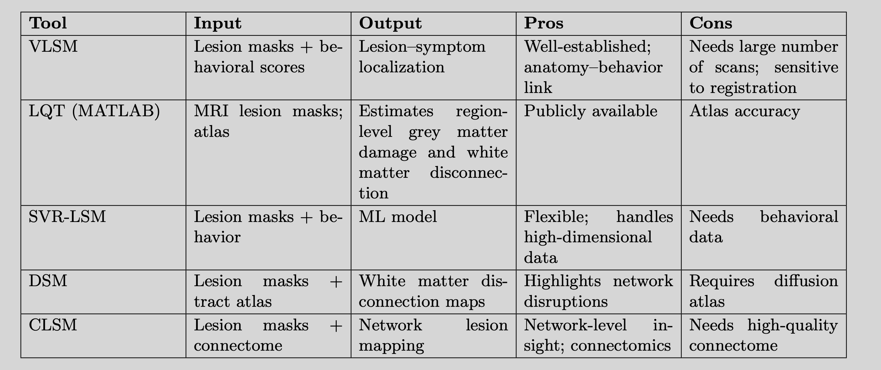
Comparison of Lesion Analysis and Mapping Tools

